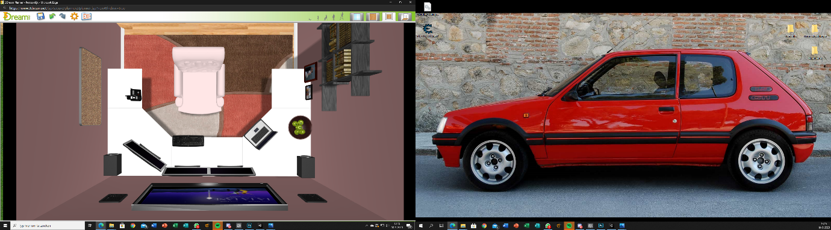

***Challenge 1, English: Describe your workplace***

Hello! I’m Luca Lardenoije from class A14M1.

In the 2 pictures above you can see my ideal workplace.

The room is not to big, but that is not necessary because everything that I want is in it. You can see that I have 3 desktop screens, I did that because it is very handy cause you then can have multiple tabblads open. For example on 1 screen is the programming program, on the second one is google so you can search things and on the 3th screen you can have some information or something else. I also have a laptop which I can take anywhere for work. On the wall I have a television to put some music on or relax and watch some television if I’m done with work and therefore I have a really good sound system. The chair is very comfortable and I want that because of backpain. On the left wall is a bookshelf with some inspiring and programming books so I always can learn something new. On the right wall you see a pin board for all the things I have to do, all the things I am busy with or the things I have finished. There is also a fruit bowl cause that is healthy. Of course I want a very good pc which can run everything. In the further future I want a much bigger office with employees but this one is something for the begin.